**Join us for a free Community Forum to help make County of San Bernardino**

**a healthier place to live, work, learn and play!**

**Insert RSVP information**

**Insert DATE  
Insert TIME**

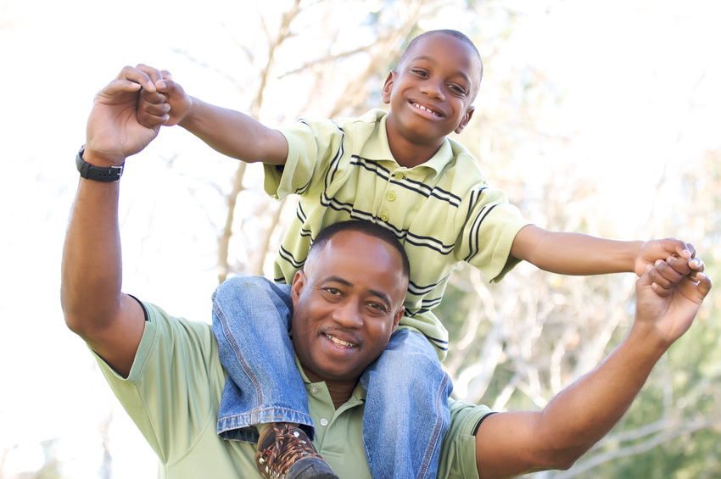

*Share your ideas for improving health in your neighborhood.*

*Become part of the transformation process.*

Insert Contact Person Information

email or phone



**The Community Transformation Plan will help improve the health of**

**County of San Bernardino County communities**

Insert ADDRESS

Insert Your

Logo Here

Organized by: